**Day 3**

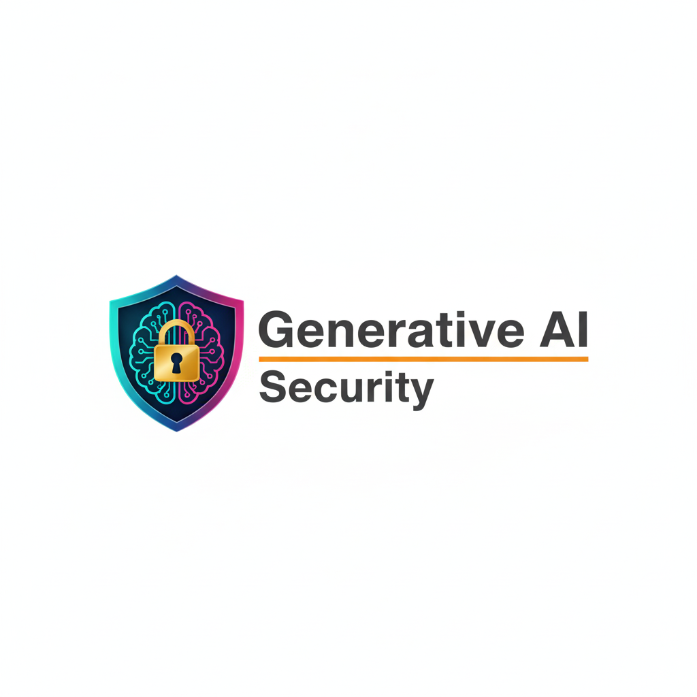

**Risk-Based Approach to AI Governance:**

**What Is an AI Risk?**

An AI risk is any possibility that an AI system may cause harm, fail, or create negative impact for users, business, or society. Simply, it talks about “*What bad thing can happen because of this AI system?”*

**Categories of AI risks:** (Generated using Gemini)

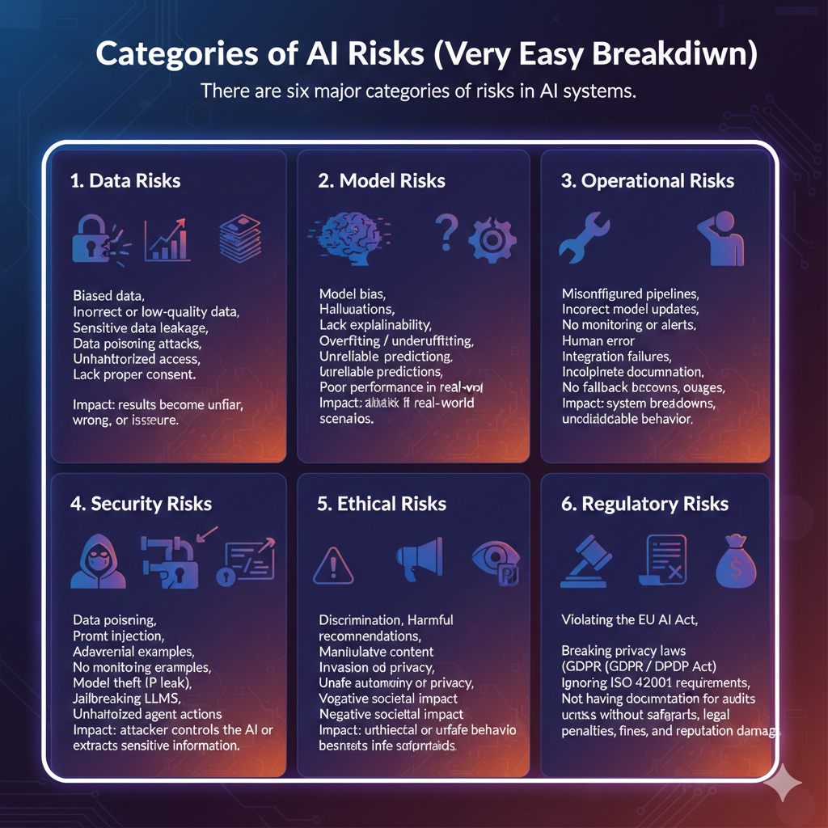

**Risk Assessment Techniques:**

AI risk assessment evaluates how dangerous an AI system could be. Risk assessment can be qualitative (Uses words, not numbers), quantitative (Uses numbers, scoring, metrics, and probabilities), or scoring-based.

**Risk Prioritization & Heat Maps:**

Heat maps help prioritize which risks need immediate attention. After, scoring risks, we organize them in a heat map:

| **Likelihood** | **Impact** | **Risk Level** |
| --- | --- | --- |
| High + High | 🔥 Red | Critical |
| High + Medium | 🟧 Orange | High |
| Medium + Medium | 🟨 Yellow | Medium |
| Low + Low | 🟩 Green | Low |

Simply,

Red risks → fix immediately  
Green risks → normal monitoring  
Yellow → moderate controls

**Linking Risks to Controls and Mitigations:**

For every risk identified, governance requires specific controls (A control is a safeguard, procedure, or mechanism put in place to reduce, prevent, or manage a specific risk.). Governance ensures every risk has a matching control.

Example Mapping:

| **Risk** | **Control / Mitigation** |
| --- | --- |
| Biased data | Fairness testing, rebalancing datasets |
| Model drift | Continuous monitoring, retraining |
| Prompt injection | Strong input validation, guardrails |
| Model theft | API rate limits, access control, encryption |
| Privacy leakage | Differential privacy, anonymization |
| Non-compliance | Documentation, human oversight, audit logs |

**Governance Workflows for Risk Acceptance & Escalation:**

If a risk cannot be fully removed, governance defines what to do. Governance workflows define who can accept, reject, or escalate high-risk AI decisions.

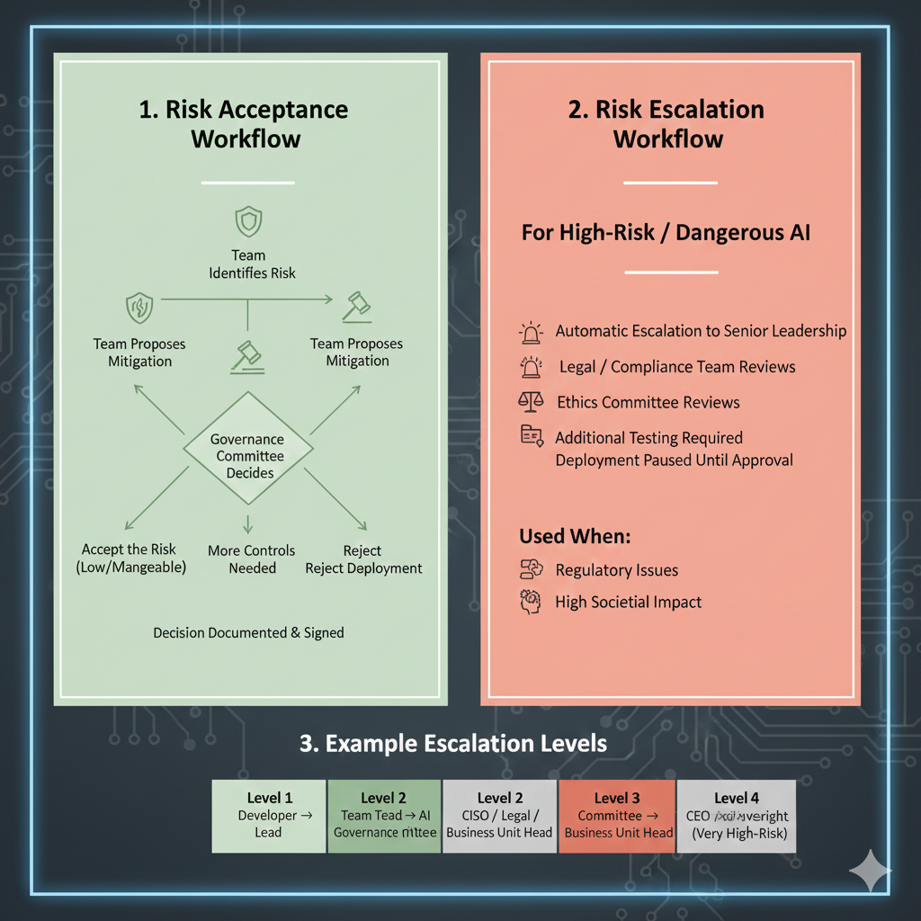

**AI Stakeholders & Their Roles:**

**AI lifecycle and stakeholders:**

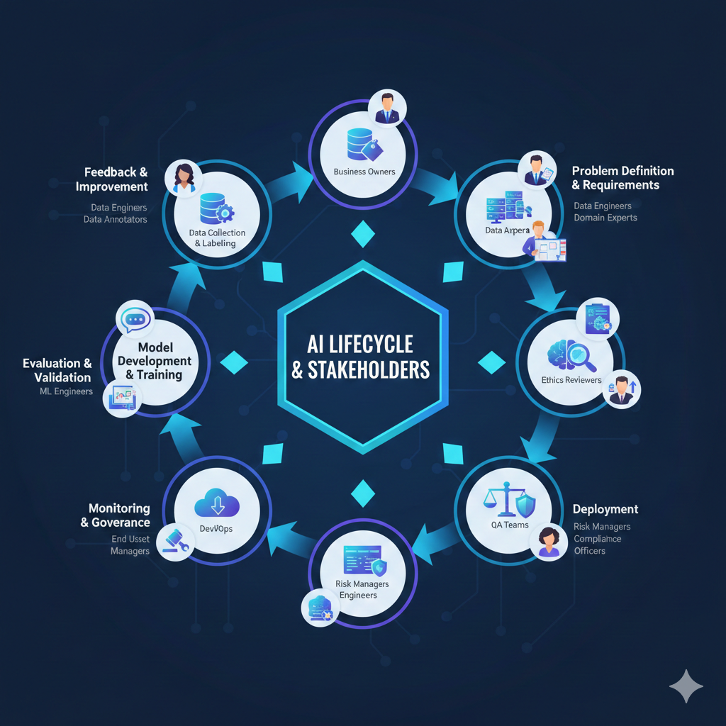

* Many people work together to make AI safe.
* ML engineers build models, data teams prepare data, security protects systems.
* Compliance ensures laws are followed, business owners justify use cases.
* Executives give final approval, users provide feedback.

**RACI Models for AI Projects:**

*RACI = Responsible, Accountable, Consulted, Informed*

Typical matrix:

| **Activity** | **Responsible** | **Accountable** | **Consulted** | **Informed** |
| --- | --- | --- | --- | --- |
| Data collection | Data team | Data owner | Legal/Compliance | Executives |
| Model training | ML Engineers | AI Lead | Security, Data | Business owner |
| Security testing | Security team | CISO | ML Engineers | Executives |
| Risk assessment | Compliance | CISO/CTO | ML + Security | Business owner |
| Deployment | ML Ops | CTO | Security + Compliance | All stakeholders |
| Monitoring | Security + ML Ops | CISO | Business | Regulators (if needed) |

RACI helps avoid confusion about who does what.

**Note: Collaboration happens during training, deployment, and monitoring.**

--The End--